Setup IDE - VS Code Installation

Visual Studio Code is the most popular code editor and the IDEs provided by Microsoft for writing different programs and languages. It allows the users to develop new code bases for their applications and allow them to successfully optimize them and debug them properly. It is a very user-friendly code editor and it is supported on all the different types of operating systems like Windows, macOS, and Linux. It has support for all the languages like C, C++, Java, Python, JavaScript, React, Node JS, etc.
Installing Visual Studio Code on Windows
Follow the below steps to install Visual Studio Code on Windows:
Step 1: Visit the official website of the Visual Studio Code using any web browser like Google Chrome, Microsoft Edge, etc.
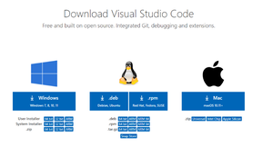
Step 2: Press the “Download for Windows” button on the website to start the download of the Visual Studio Code Application.
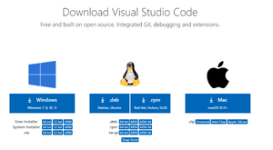

Step 3: When the download finishes, then the Visual Studio Code icon appears in the downloads folder.
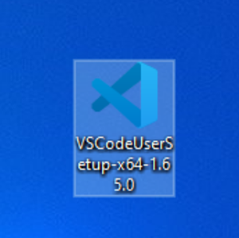

Step 4: Click on the installer icon to start the installation process of the Visual Studio Code.
Step 5: After the Installer opens, it will ask you for accepting the terms and conditions of the Visual Studio Code. Click on I accept the agreement and then click the Next button.
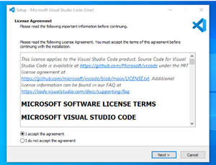

Step 6: Choose the location data for running the Visual Studio Code. It will then ask you for browsing the location. Then click on Next button.
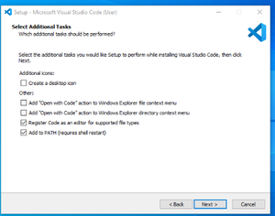

Step 7:Then it will ask for beginning the installing setup. Click on the Install button.
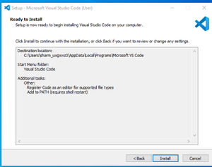

Step 8: After clicking on Install, it will take about 1 minute to install the Visual Studio Code on your device.
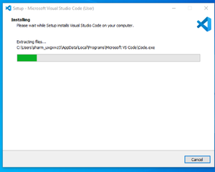

Step 9: After the Installation setup for Visual Studio Code is finished, it will show a window like this below. Tick the “Launch Visual Studio Code” checkbox and then click Next.
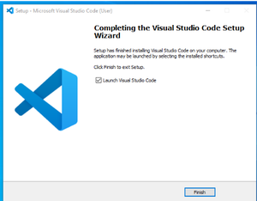

Step 10: After the previous step, the Visual Studio Code window opens successfully. Now you can create a new file in the Visual Studio Code window and choose a language of your choice to begin your programming journey!
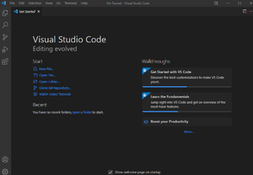

So this is how we successfully installed Visual Studio Code on our Windows system.

After installation, you would need to open the extensions tab and download the following extensions -
1. Code Runner ~ Jun Han (this will be used to run our JavaScript)
2. Bracket Pair Colorization Toggler ~ Dzhavat Ushev (this will colourize bracket pairs in our code)
3. Beautify ~ HookyQR
4. Prettier - Code Formatter ~ Prettier
5. Live Server ~ Ritwick Dey (Lets us serve our program on localhost)

